Biography

Franz Nietlispach, Switzerland, Wheelchair racing / Handcycling

14-times Paralympic Champion, 20-times World Champion

Address:  Franz Nietlispach  Leimgasse 1  CH-4313 Zeiningen  Switzerland  franz@nietlispach.ch  www.nietlispach.ch |  | 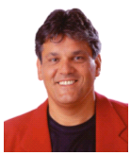 | Business:  Novartis International AG  Franz Nietlispach  Head of Sport Sponsoring Dept.  CH-4002 Basel  Switzerland  franz.nietlispach@novartis.com  www.novartis.com
Family:  Franz was born on April 2, 1958 in Muri, Switzerland. He was the second youngest of totally 12 kids (8 sisters, 3 brothers). At the age of 15 he got a spinal cord injury by falling from a cherry tree.  1979 he got in touch with Doris and got married on August 31,1985.  September 21, 1990 they got a son named Roman and 4 years later, October 27, 1994 a girl named Celina. They live in a nice house in a small town in Switzerland, close to the German border. |  |  |  |  | 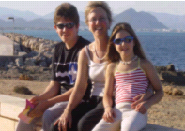
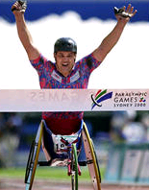 | Career Highlights - Wheelchair Racing:  Totally 14-times Paralympic Champion (1980-2000)  1984 5-times gold medalist Paralympic Games Stoke Mandeville  1988 6-times gold medalist Paralympic Games Seoul  1990 Marathon World Champion, Assen NL  1994 3-times World Champion, Berlin  1995 First win Boston Marathon  1996 Marathon Paralympic Champion, Atlanta, USA  1997 Winner of Boston Marathon (1997 - 2000)  2000 Marathon Paralympic Champion, Sydney, AUS  2001 2-times European Champion, Nottwil, SUI  2001 World Record 1500m (2.56.61, still official on Dec. 31,2005)  more details: http://www.nietlispach.ch
Career Highlights - Handcycling:  2nd European Championship 2003 time trial  3rd European Championship 2003 road race  3rd Paralympic Athens 2004, time trial  2nd European Championship 2005, time trial  1st and World Champion 2006, time trial |  |  |  | 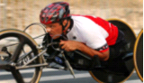
All results and more infos: http://www.nietlispach.ch

November 11, 2006/FN

